
MANGALORE INSTITUTE OF TECHNOLOGY & ENGINEERING
(A Unit of Rajalaxmi Education Trust®, Mangalore)
Autonomous Institute affiliated to V.T.U., Belagavi, Approved by AICTE, New Delhi.
Accredited by NAAC with A+ Grade, An ISO 9001: 2015 Certified Institution

DEPARTMENT OF ELECTRONICS & COMMUNICATION ENGINEERING
(Accredited by NBA)
Major Project Phase -1
(Subject Code: BEC685)
“Longitudinal & Lateral Control of Autonomous Vehicles”

Project Associates:

- Pranam N | USN: | 4MT22EC074
- Shetty Srajan | USN: | 4MT22EC103
- Swasthik | USN: | 4MT22EC113
- Swathi | USN: | 4MT22EC114
Under the Guidance of :
Dr.Vinayambika S Bhat HoD Dept of ECE
Dean,Quality assurance

Sahana G Kundar Assistant Professor

Introduction
- Autonomous vehicles (self-driving cars) are revolutionizing transportation by reducing human intervention and improving road safety. These vehicles rely on advanced control systems to manage speed and steering accurately. Two crucial aspects of vehicle control are longitudinal control (managing speed through acceleration and braking) and lateral control (steering to maintain lane position).
- In this study, we use the CARLA simulator, an open-source simulation platform, to develop and evaluate
these control techniques in a realistic, virtual driving environment. Autonomous vehicles use sensors such as LiDAR. In the CARLA simulator, LiDAR is used to help a virtual car "see" its surroundings, just like in real life.
- The project uses virtual sensors and real-life driving situations like turning or braking to see how well the car
controls work, using tools to track and understand its actions.
- It also checks how the system handles sudden problems, looks at ways to improve control, and helps build
smarter, safer self-driving cars.

Problem Statement
- Designing to develop longitudinal and lateral control of autonomous vehicles to avoid collisions and reduce human driving errors. Traffic congestion and accidents are rising. So to manage speed and steering to ensure safety, comfort, and proper lane following. There is a critical need for smart, adaptive control systems that can reliably handle dynamic environments to minimize the risk of accidents, weak control can cause accidents. Reliable, intelligent vehicle management is necessary to handle dynamic road conditions

Literature Survey

S.NO  . | Authors | Paper Title | Year | Method Used
1 | F. Wei, W.  Wang, and H. Liu | A design of autonomous driving system in Carla simulator | 2024 | The authors used sensors are GPS, LiDAR, Cameras, IMU, Radar. Methods are PID Control, Pure Pursuit, Path Planning Algorithms.  Limitations are GPS inaccuracies, LIDAR and radar performance in poor weather, path planning under complex traffic conditions.
2 | A. Charroud, K. El Moutaouakil, et.al. | Localization and mapping for self-driving vehicles: A survey | 2023 | The paper uses Simultaneous Localization and Mapping (SLAM) for vehicle localization and mapping. They used sensors are LiDAR, cameras, and IMU.  Limitations are sensor noise, environmental conditions affecting sensor accuracy, and complexity in real-time processing.

Literature Survey

S.No. | Authors | Paper title | Year | Method Used
3 | Y. Liu, et.al. | Longitudinal and lateral control strategies for automatic lane change to avoid collision in vehicle high-speed driving," Sensors | 2023 | The paper uses PID control for longitudinal control and Pure Pursuit for lateral control in high-speed lane changes. The sensors used include LiDAR, cameras, and radar.  Limitations include sensor fusion challenges and difficulties in handling high-speed maneuvers in dynamic environments.
4 | S. Kuutti, et.al. | A survey of deep learning applications to autonomous vehicle control | 2021 | The paper uses PID control and MPC (Model Predictive Control) for longitudinal and lateral collision avoidance. LIDAR, radar, and cameras are used as sensors for environment perception. Limitations include high computational demand for MPC and sensor fusion challenges in dynamic environments.
5 | S. Kuutti, et.al.  . | Deep learning for LiDAR point clouds in autonomous driving: A review | 2021 | Methods used include Deep learning for LiDAR point clouds. Sensors used are LiDAR. Limitations are high computational cost, large dataset requirements, difficulty in real-time processing.

Literature Survey

S.No. | Authors | Paper Title | Year | Method Used
6 | S. Kuutti, et.al. | A survey of deep learning applications to autonomous vehicle control | 2021 | The paper uses deep learning methods for vehicle control, dependency, and challenges in real-time decision-making. including Convolutional Neural Networks (CNNs) and Reinforcement Learning (RL). Sensors used include cameras, LIDAR, and radar for perception. Limitations include *high computational cost, data
7 | Y. Wang, et.a | Longitudinal and lateral control of autonomous vehicles in  multi-vehicle driving environments | 2020 | Methods used: Model Predictive Control (MPC), PID control. Sensors used: LIDAR, radar, cameras, GPS. Limitations: High computational cost, sensor fusion challenges, complexity in multi-vehicle environments.
8 | M.  Elhousni and X. Huang | A survey on 3D LiDAR localization for autonomous vehicles," | 2020 | Methods used are 3D LiDAR localization, SLAM, Kalman filter. They used sensors are 3D LiDAR, IMU. Limitations are High computational cost, issues in dynamic environments, difficulty in sensor calibration.

Methodology/Block Diagram
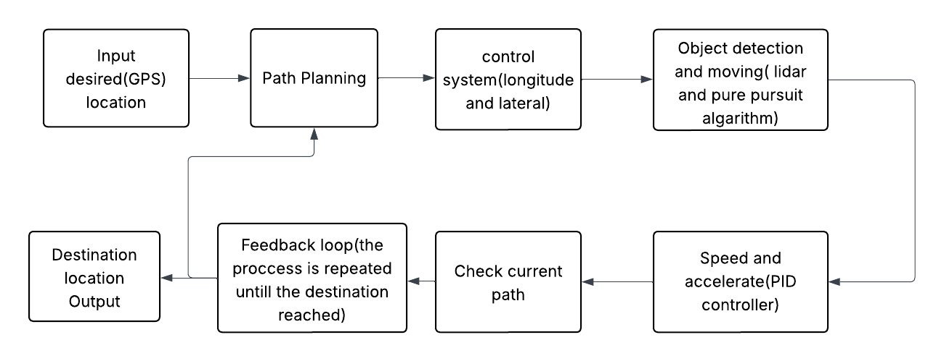
Fig 1: Block Diagram Longitudinal & Lateral Control of Autonomous Vehicles.

Methodology
- Setting Up the Simulation: Use the CARLA simulator, a virtual driving world, to test how the car would behave in real life.
- Collecting Data: Use LiDAR to understand the surrounding conditions, roads, lanes, and obstacles.
- Understanding the Environment: Process the collected data to detect lanes, obstacles, and road conditions.
- Combining Speed and Steering: Make sure the speed and steering work together for smooth and safe driving.
- Controlling Speed (Longitudinal Control): Use a PID controller (a basic control system) to adjust the car’s speed by controlling acceleration and braking.

Methodology
- Controlling Steering (Lateral Control): Use smart steering techniques (like Pure Pursuit) to keep the car in its lane and take turns safely.

- Combining Speed and Steering: Make sure the speed and steering work together for smooth and safe driving.

- Testing in Different Scenarios: Run tests in various road conditions (straight roads, curves, intersections) inside CARLA to check if the car follows the rules properly.

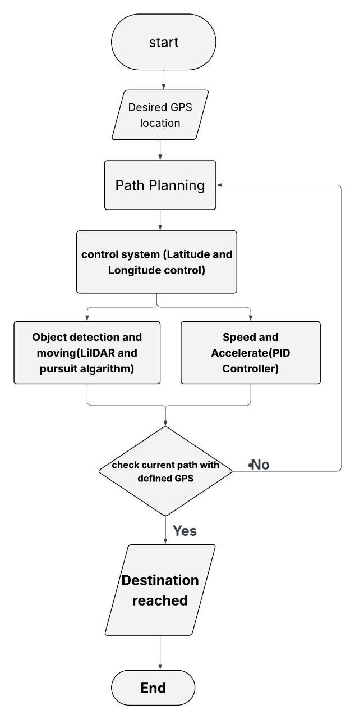
Flowchart
  - Start – Begin the navigation process.

  - Desired GPS Location – Set the target GPS coordinates.

  - Path Planning – Plan a route to the destination.

  - Control System – Adjust movement based on latitude and longitude.

  - Object Detection and Moving – Detect obstacles and navigate around them.

  - Speed and Acceleration – Control speed using a PID controller.

  - Check Current Path with Defined GPS – Verify if the destination is reached.

  - Destination Reached – Confirm arrival at the target location.

  - End – Stop the navigation process.
Fig 2: Flow chart for Longitudinal & Lateral Control of Autonomous Vehicles.

Expected Outcome
    - Designing a smart system self-driving cars to control their speed and steering. It uses sensors to keep a safe distance from other vehicles and stay in the correct lane. This system adjusts in
real-time to road conditions, making driving safer, smoother, and more comfortable.

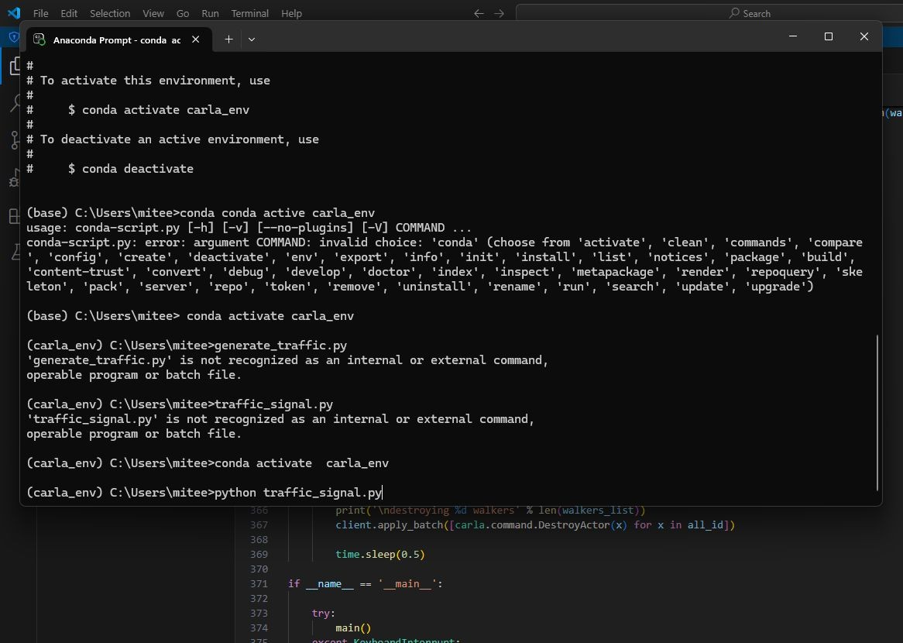
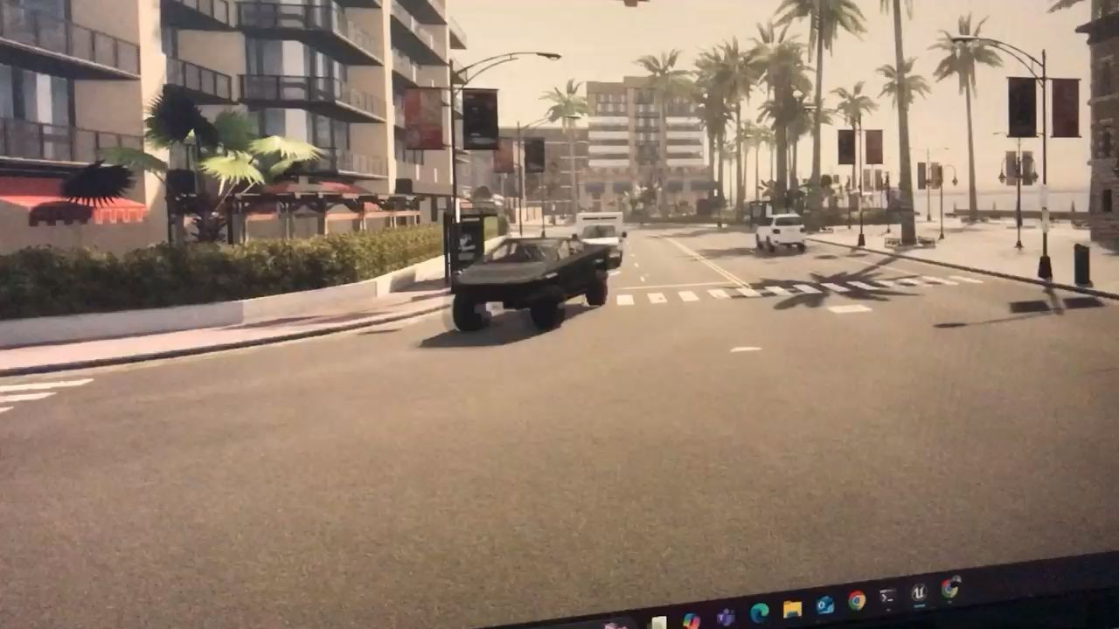

Reference
- S. Zhang, J. Ou, G. Deng, and Z. Xu, "Research on hierarchical control of automobile automatic emergency braking system based on V2V," SAE International, Warrendale, PA, USA, 2021.

- F. Wei, W. Wang, and L. Hanwen, "A design of longitudinal and lateral controllers for autonomous driving system in Carla simulator," University of Sussex, 2024.

- C. M. Massera, D. Wolf, V. Grassi Jr, and F. Osório, "Longitudinal and lateral control for autonomous ground vehicles," in IEEE Intelligent Vehicles Symposium (IVS), 2020.

- A. Dosovitskiy, G. Ros, F. Codevilla, A. Lopez, and V. Koltun, “CARLA: An open urban driving simulator,” 2024.

- F. Wei, W. Wang, and L. Hanwen, “A design of longitudinal and lateral controllers for autonomous driving system in Carla simulator,” University of Sussex, 2025.

Reference
- Y. Li, L. Ma, Z. Zhong, F. Liu, D. Cao, J. Li, and M. A. Chapman, "Deep learning for LiDAR point clouds in autonomous driving: A review," IEEE Transactions on Neural Networks and Learning Systems, vol. 32, no. 8, pp. 3412–3432, Aug. 2021,doi:10.1109/TNNLS.2020.2994909.
- Y. Wang, Q. Shao, J. Zhou, H. Zheng, and H. Chen, "Longitudinal and lateral control of autonomous vehicles in multi-vehicle driving environments," IET Intelligent Transport Systems, vol. 14, no. 9, pp. 1120–1128, 2020, doi: 10.1049/iet-its.2019.0846.
- Elhousni and X. Huang, "A survey on 3D LiDAR localization for autonomous vehicles,“ in Proceedings of the IEEE Intelligent Vehicles Symposium (IV), Las Vegas, NV, USA, Oct.2020, pp. 1879–1884, doi: 10.1109/IV47402.2020.9304812.

